**New macOS Testing Playbook**

This playbook outlines the structured process for testing the new macOS (Sequoia) Last year. The goal is to ensure a seamless experience for Walmart users ones as the new macOS is released.

**Product Manager Role**

* **Determine the target audience:** ensure that all key teams are targeted for testing, and thoroughly review the existing list from last year before sending the email communications. <https://business.apple.com/>
* **Communications:** PM needs to send out the initial communication to all testers and managers, also need to communicate to the team about the kick-off dates and assign cards for the engineer assigned to assist.
* **Manager Follow-Up**: The PM will periodically follow up with testers, managers, and teams to maintain engagement and encourage consistent feedback.
* **Timing and Cadence**: Set up regular check-ins (Weekly or bi-weekly) to gauge the progress and ensure any emerging issues are addressed promptly.

**Engineering Support**

* **Resource Allocation**: Assign at least two Mac engineers to support the project.
* **Engineer Responsibilities**:
  + **Channel Support**: Respond to concerns and questions within the Teams channel, providing guidance and quick solutions.
  + **Documentation**: Capture feedback and findings from the channel in the Excel file, ensuring thorough documentation.
  + **Enrollment Assistance**: Assist testers who encounter issues with enrollment or other aspects of the beta testing process.
* **To ensure a successful test and support experience, engineers should coordinate with support teams and testers to validate the following:**
* **Do we need to have a lab setup?**

**Applications Test**

* **Office for Mac Suite: Mac team should get the app team involved in testing**
* **Microsoft Word: What testing do >**
* **Microsoft Excel**
* **Microsoft OneNote**
* **Microsoft PowerPoint**
* **Microsoft Outlook**
* **Microsoft Teams**
* **Google Chrome**
* **Safari**
* **Reach out to Shahzad for security apps**

**Other Applications**

* **Sammy app**
* **Company Portal**
* **SelfService**
* **App Store**
* What other apps we need to add to the list

**Tools**

* **Time/Location**
* **FaceTime**
* **Find My**
* **Wireshark**
* **Forcepoint Decryption Utility:**

**1. Initial Communication**

* **Audience**: The communication is sent to managers and teams involved in the testing process.
* **Email Outline**:
  + **The email should welcome participants to the macOS Beta Testers Group and tell them how important their job is in testing for the corporate environment.**
  + **Enrollment Instructions**: Detailed steps on how testers can enroll their Macs to install the new macOS.
  + **Team Channel Access**: Clear directions on where to find the designated Teams channel to share findings and user experiences.
  + **Encouraging Feedback**: Remind users of the importance of sharing feedback in the Teams channel to help capture a broad range of experiences.

Welcome: <[Email Template](https://teams.wal-mart.com/:u:/r/sites/Apple-Engineering/Shared%20Documents/General/Business%20Review/Product%20Portfolio/macOS%20Beta%20Testing/Welcome%20to%20the%20macOS%20Beta%20Testing%20Program!.eml?csf=1&web=1&e=MI2epW)>

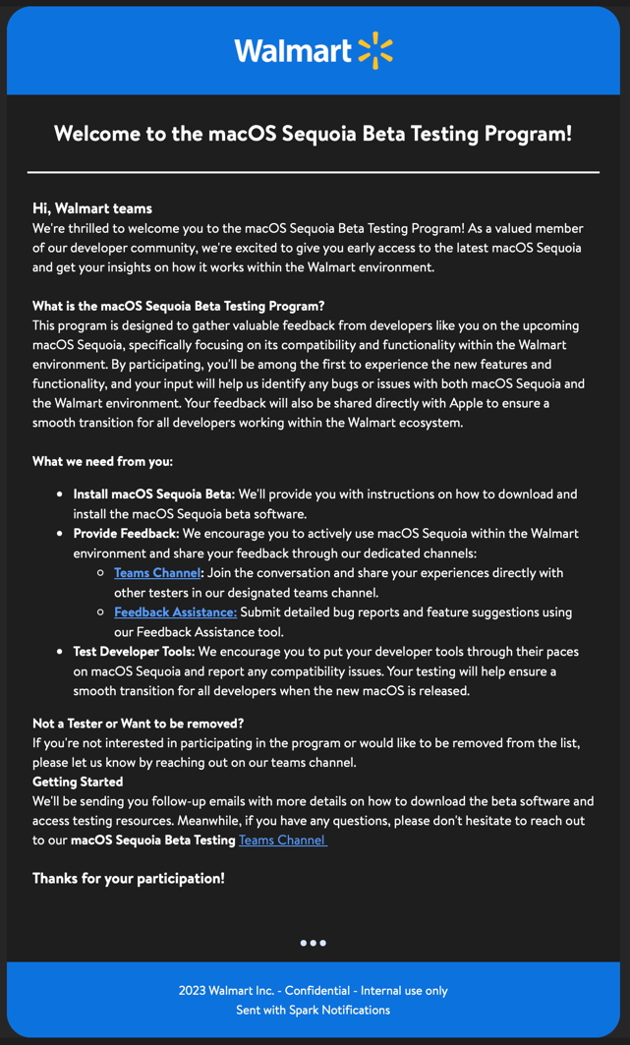

Enrolment <[Email Template](https://teams.wal-mart.com/:u:/r/sites/Apple-Engineering/Shared%20Documents/General/Business%20Review/Product%20Portfolio/macOS%20Beta%20Testing/macOS%20enrolment%20for%20Walmart%20and%20AppleSeed.eml?csf=1&web=1&e=cohGIZ)>

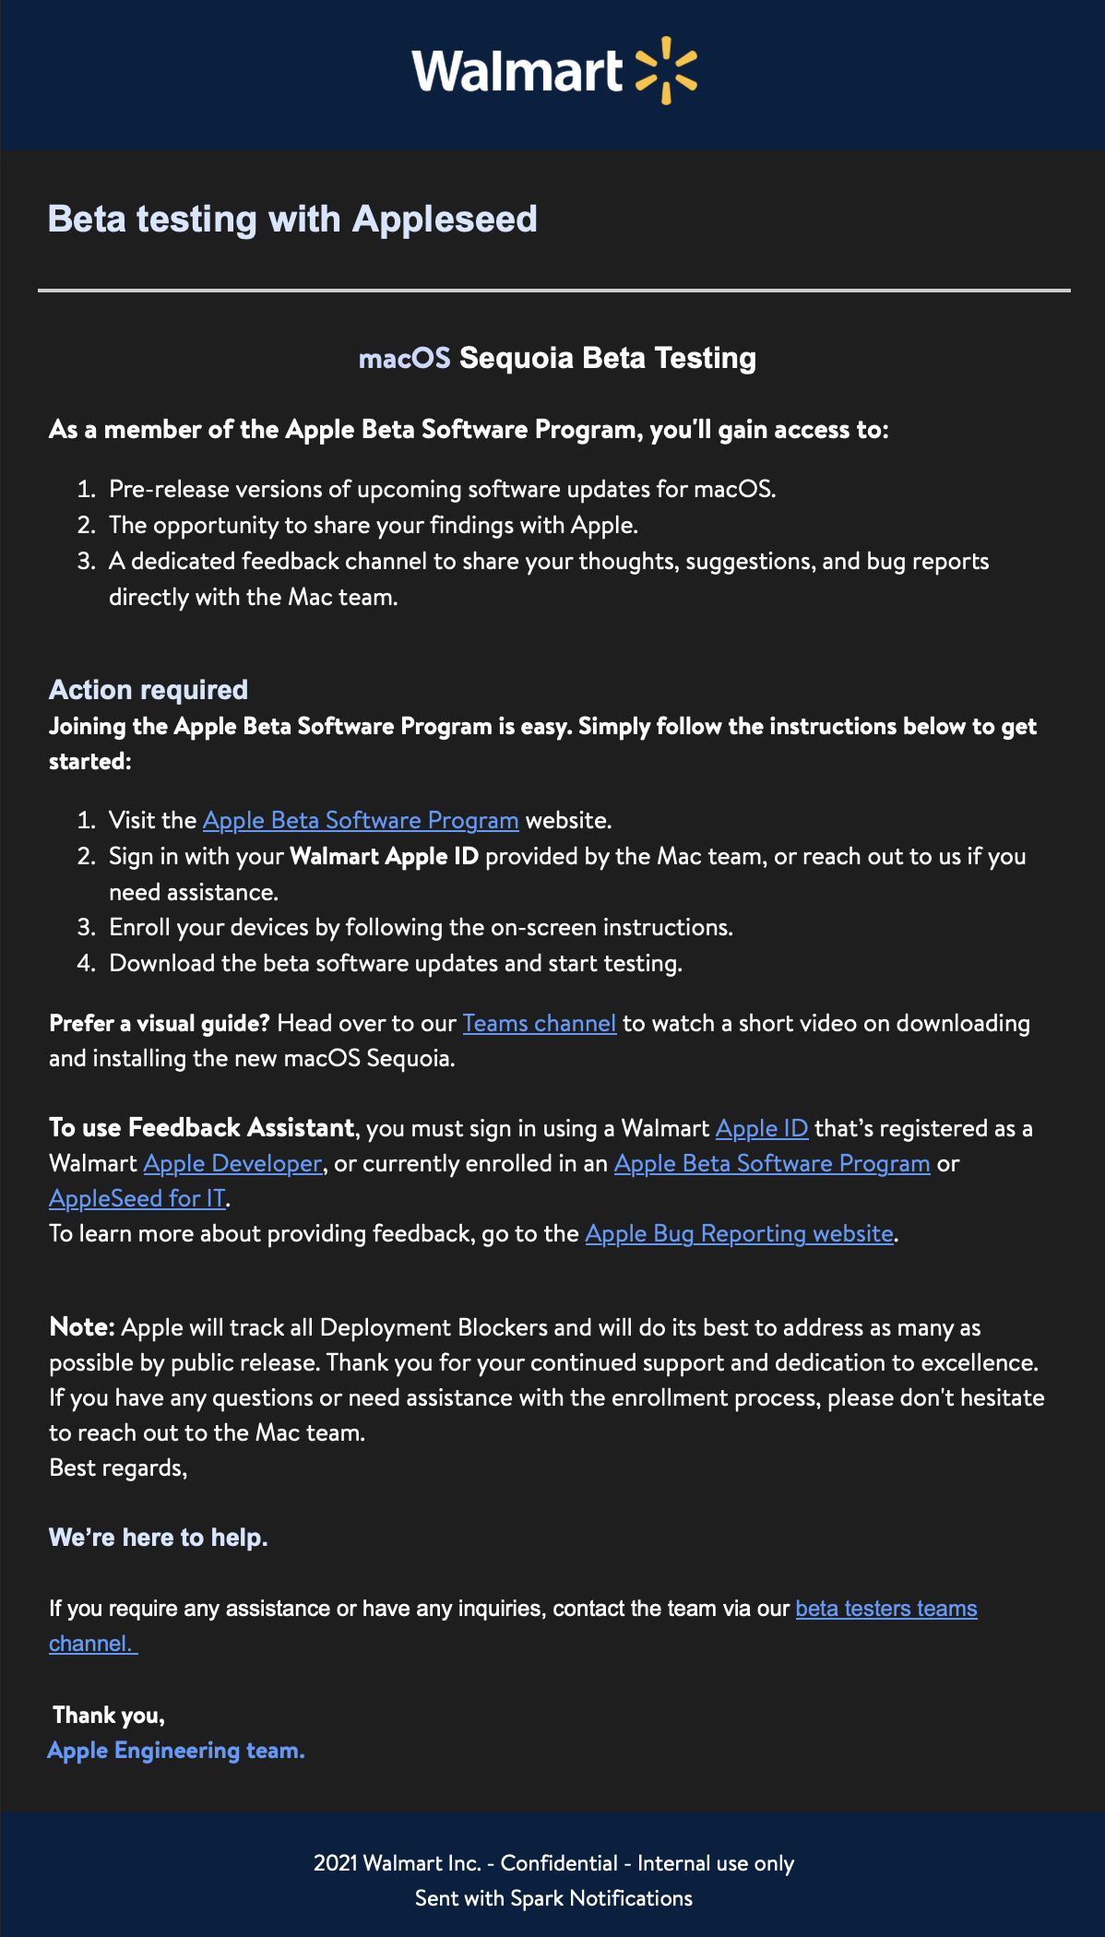

**2. Feedback Collection,** Before the email communication is sent out to all testers, the PM must create the team's channel.

**Teams Channel**: Testers are encouraged to regularly visit the Teams channel to share their customer experience and report any issues they encounter. The channel serves as the primary platform for real-time interaction and troubleshooting.

* **Feedback Schedule**: Set up a regular cadence for testers to submit feedback (e.g., weekly or bi-weekly updates), creating a consistent flow of insights.

**Excel File: (macOS_Testing.xlsx)** A centralized Excel file is maintained to document all findings, user experiences, and observations during the testing process. This file ensures that information is consistently organized and readily accessible for review and follow-up actions. The PM should include this document in a weekly team meeting to review any identified issues, discuss progress, and help structure the data for more effective tracking and resolution.

**3. Data Collection & Review**

* **Pre-Launch Meetings**: As we approach the macOS Sequoia release date, hold a series of meetings with the mac & support teams to gather all data, discuss the findings, and identify any remaining concerns.

**4. Retrospective for Improvement:**

* **Collect feedback from the team** on what went well and areas for improvement. This retrospective insight will be essential for refining the process in future testing cycles.

**4. Timing Recommendations**

* **Initial Communication Timing**: Begin reach out to managers and testers 1-2 weeks before testing begins.
* **Feedback Collection Timing**: Set weekly or bi-weekly intervals for feedback, helping keep a steady flow of input.
* **Pre-Launch Data Collection**: Schedule final review meetings 2-3 weeks before the official macOS release, giving the team time to address last-minute findings or issues.

This playbook provides a clear, organized structure to guide our macOS testing, ensuring readiness for a successful launch.

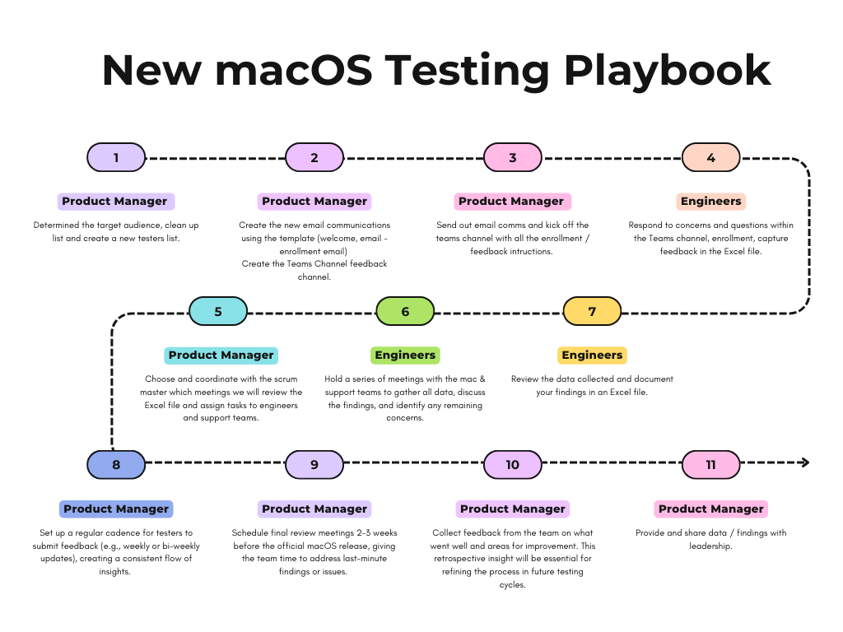

Task > Clean up and update ABM tester list. (Emailed George and he mentioned that I would need to create a case, for now what I can do is deactivate the accounts.) Done

Task > Managed Application Information > download the data from Pauls page and going to add mac team owners

<https://confluence.walmart.com/display/GTOCSM/Managed+Application+Information>

Task > Security teams info and add it to the Confluence page. > In progress

Task > Mac Eng testing, need to generate the tracker for config profiles, scoping, etc. > Meeting with Cham and Cody tomorrow, Cham has already created something similar we can use.

[Tahoe-Jamf Validation.xlsx](https://teams.wal-mart.com/:x:/r/sites/Apple-Engineering/Shared%20Documents/General/Business%20Review/Product%20Portfolio/macOS%20Beta%20Testing/Tahoe-Jamf%20Validation.xlsx?d=w550cbf4d231e49ccae64bf302328a761&csf=1&web=1&e=Wkl5bQ) - Agenda for the team meetings.

Task > Generate the application owner testing, including security stack.

[macOS Third party apps_Tahoe_Testing.xlsx](https://teams.wal-mart.com/:x:/r/sites/Apple-Engineering/Shared%20Documents/General/Business%20Review/Product%20Portfolio/macOS%20Beta%20Testing/macOS%20Third%20party%20apps_Tahoe_Testing.xlsx?d=w79317d10e4f246928d5ba0701418777c&csf=1&web=1&e=BiSw4Y) - Update owners Jesper Johansson Complete, Jesper is out on PTO [<Jesper.Johansson@walmart.com](mailto:<Jesper.Johansson@walmart.com)> Need to create an ABM account for him so he can help test.

Task > Bug tracker for Customers. Completed, Need to share with the testers in teams channel.

[macOS_Tahoe_Bug_Tracker.xlsx](https://teams.wal-mart.com/:x:/r/sites/Apple-Engineering/Shared%20Documents/General/Business%20Review/Product%20Portfolio/macOS%20Beta%20Testing/macOS_Tahoe_Bug_Tracker.xlsx?d=w0ebd596de23e4bbeab00bab9479cdeca&csf=1&web=1&e=V6G6Do)

Task > Create a RACI chart – what this means is who is reporting and who will create the Apple case for the testers tech. For example, if a tec in support will have testing and feedback we need to assing this to a mac team eng. I need to have the list drafted for nex team meeting so we can assign it to the team members.

Task >Manager to hold people responsible (Ainettte)

Task > Create the instructions comms.

Task > kick-off the new teams channel.

Task >Make all the testing results available for users and management – what are we going to use (what tool)

Next steps:

Teams channel > Create a teams channel and move users to that channel.

Jamf clean up / export > Cham will create the list of what should be removed

Initial (cham/Cody/Carlos) review next week, team will test if they work for Tahoe. Next, when the list is created we present to consul for the team.

When do we add owners team? – when Public Beta is avaiable. This same time I send out the email comms for testers.

Let app owners choose if they want to open a apple case for a simple issue.

Follow a standar template for any changes in JAMF.

Follow up with the team and see what they can recommend we can incorporate for the macOS testing— what did they learn (class is next week)

**macOS Tahoe Beta Testing Kickoff - Task Tracker**

### **Accounts & Access**

* **Task: Clean up and update ABM tester list - met with Cham and Cody, Cham is preparing a list so we can go over it in Console. Completed**  
    
   **Notes:**
  + **Emailed George – needs a case to proceed. Completed**
  + **For now, deactivate the accounts manually.**
* **Task: Jamf cleanup/export list**  
   **Owner: Cham**  
   **Next Step:**
  + **Cham to create a list of items to be removed Jamf. Tuesday – 15th**
  + **Team (Cham/Cody/Carlos) to review next week. Completed**
  + **Cham created a list showed us a list downloaded from jamf**
  + **Present final list to Consul team.**
  + <https://confluence.walmart.com/display/GTOCSM/Managed+Application+Information>

### **Documentation & Data Tracking**

* **Task: Managed Application Information**  
    
   **Next Step:**
  + **Download the data from** [**Paul's Confluence page**](https://confluence.walmart.com/display/GTOCSM/Managed+Application+Information) **- In Progress**
  + **Add Mac team owners.**
* **Task: Add Security Teams Info to Confluence page**

**Next Step:**

* **Task: Create tracker for configuration profiles, scoping, etc.**  
    
   **Next Step:**
  + **Meeting with Cham and Cody scheduled.**
  + **Use the existing tracker template from Cham.**
* **Task: Generate app owner testing list (include security stack)**

**Next Step:**

* **Task: Make all testing results available to users and management**  
  **Next Step:**
  + **Decide which tool/platform to use.**

### **Roles & Responsibilities**

* **Task: Create a RACI chart.**  
    
   **Next Step:**
  + **Identify who will report vs. create Apple cases.**
  + **Assign engineers to specific testers.**
  + **Draft for next team meeting.**
* **Task: Assign responsibility to manager (Ainette)**
* **Task: Allow app owners to decide on opening Apple cases for simple issues.**

**Next Step:**

* + **The welcome email will let testers know that it's up to the team to open an Apple case for any small problems that don't get in the way of deployment. We may also have a support page somewhere.**

### **Communications**

* **Task: Create instructions/comms for testers**

**Task: Kick off new Teams channel**  
 **Status: Monday July – 14**

**Next Step:**

* + **Create Teams channel. Completed**
  + **Move all testers and relevant into the new channel. July 14**
* **Task: Send comms to testers (when public beta is available).**

### **Standards & Best Practices**

* **Task: Follow standard template for all JAMF changes.**

### **Wins**

### **macOS Tahoe Beta Testing Tracker and Automated User Testing**

Our team developed an automated script to systematically validate application compatibility with the upcoming macOS release, ensuring efficient and comprehensive testing across our critical software ecosystem. The script will automatically launch and assess applications, proactively identifying and addressing potential software conflicts to reduce manual testing efforts and support a smooth technological transition.

Additionally, we will track via our Tahoe Validation Sheet by taking a snapshot from Jamf of all policies, profiles, scripts, and extension attributes to ensure they are working for macOS Tahoe. While the user automated testing flow will eventually include this, each validation task will initially be assigned to team members for manual verification.